MEDICAL INVENTORY MANAGEMENT

**COLLEGE NAME:**  Shree Venkateshwara Arts and Science college

**COLLEGE CODE:** brubd

**TEAM ID:** NM2025TMID20952

**TEAM MEMBERS:**

**Team Leader Name:** Swathi. S

**Email:** swathis2023aids@gmail.com

**Team Member 1:** Manimegala. A

**Email:** [manimegalaaaids@gmail.com](mailto:manimegalaaaids@gmail.comiriprasathcyber28@gmail.com)

**Team Member 2:** Nasima Banu. A

**Email:** [nasimabanua2023aids@gmail.com](mailto:nasimabanua2023aids@gmail.com)

**1.INTRODUCTION:**

* 1. **Project Overview**

Effective inventory management is critical in healthcare settings to ensure the availability of essential medical supplies, equipment and pharmaceuticals. Medical inventory management involves tracking , storing and managing these resources to meet patient needs while minimizing waste, reducing costs and maintaining regulatory compliance.

* 1. **Purpose**

The primary purpose of Medical inventory management is to ensure the efficient and effective management of medical supplies, equipment and pharmaceuticals in healthcare settings.

**DEVELOPMENT PHASE:**

* Creating developer account.

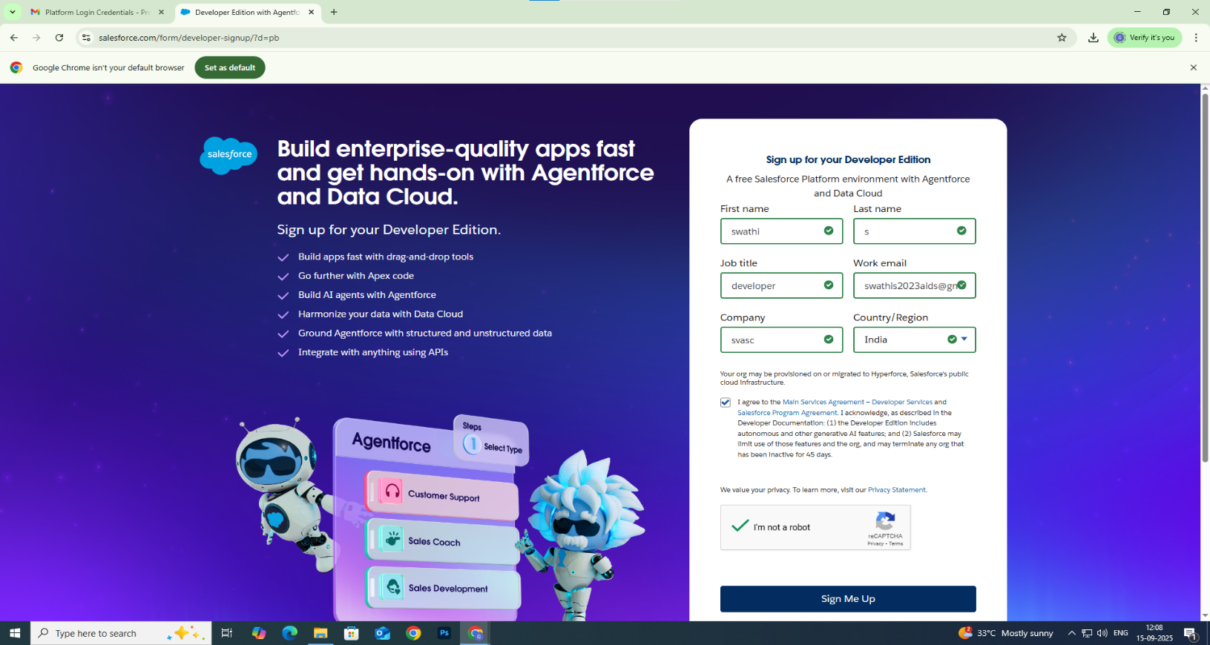

* Creating a product object.

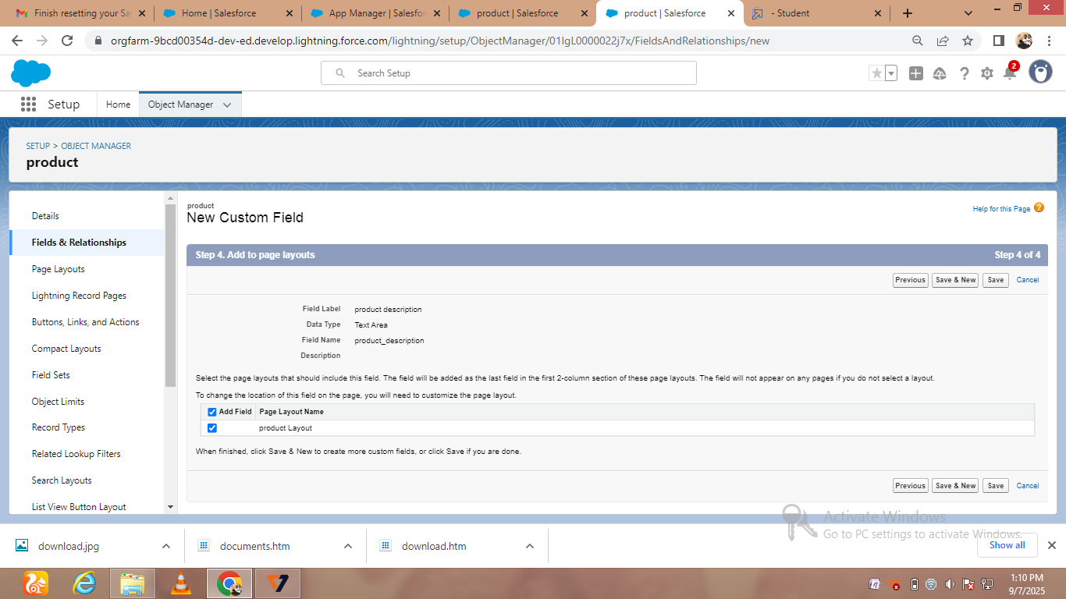

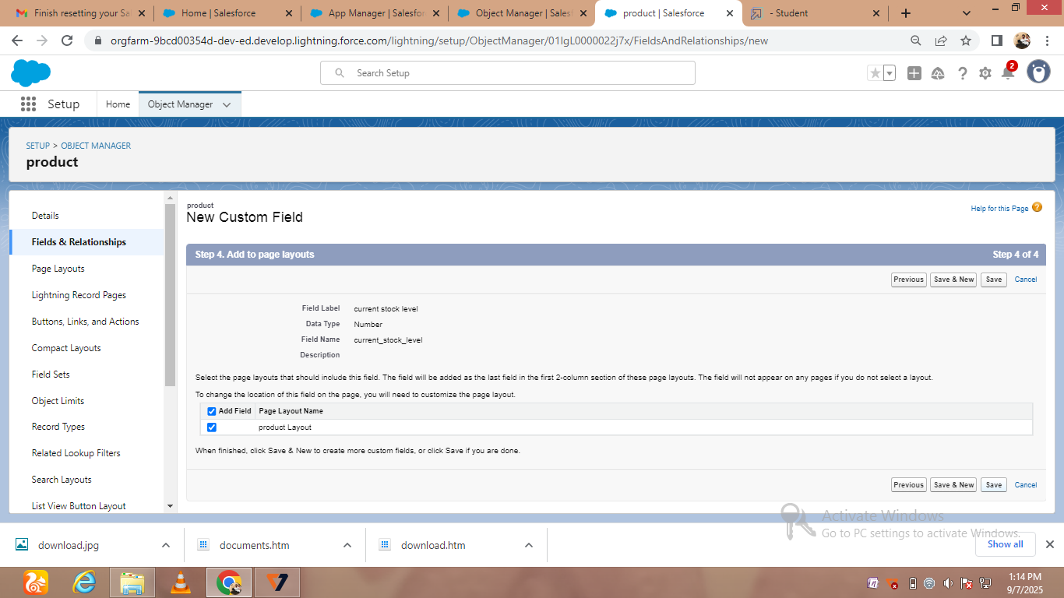

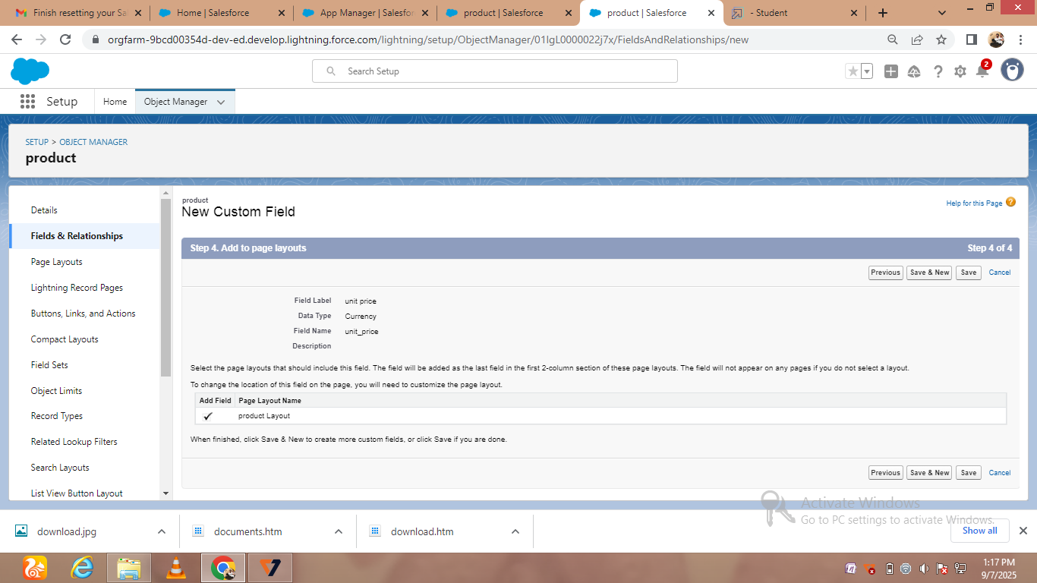

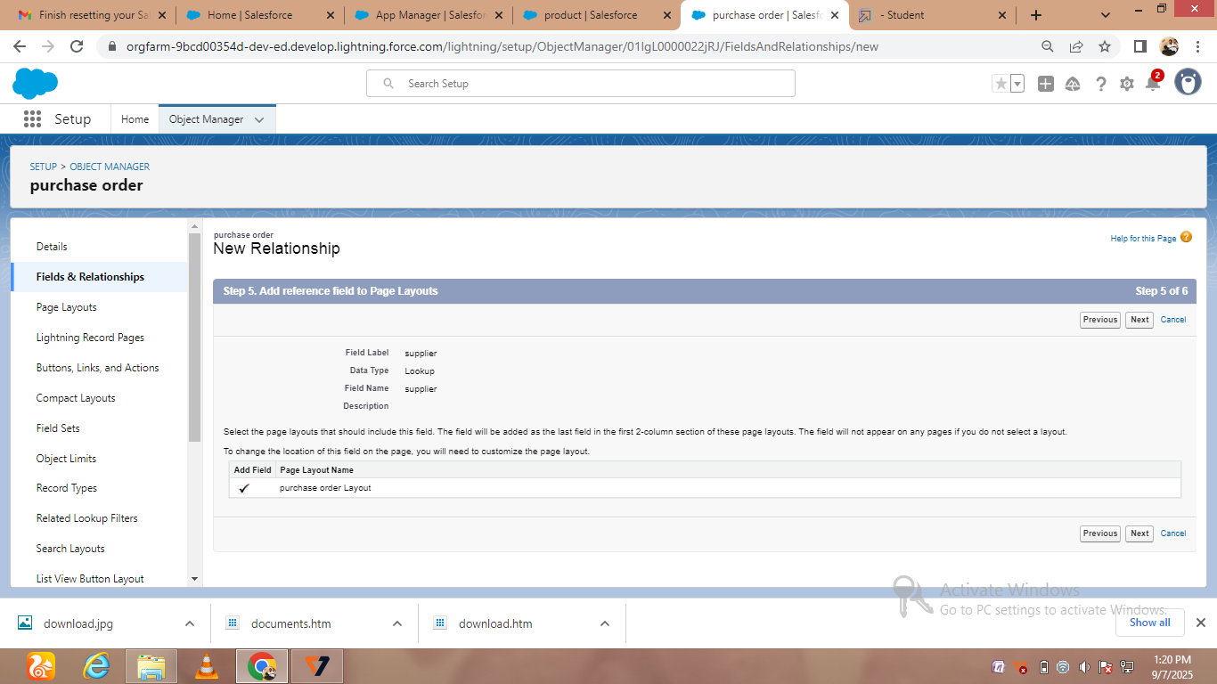

* Creating new Custom field id

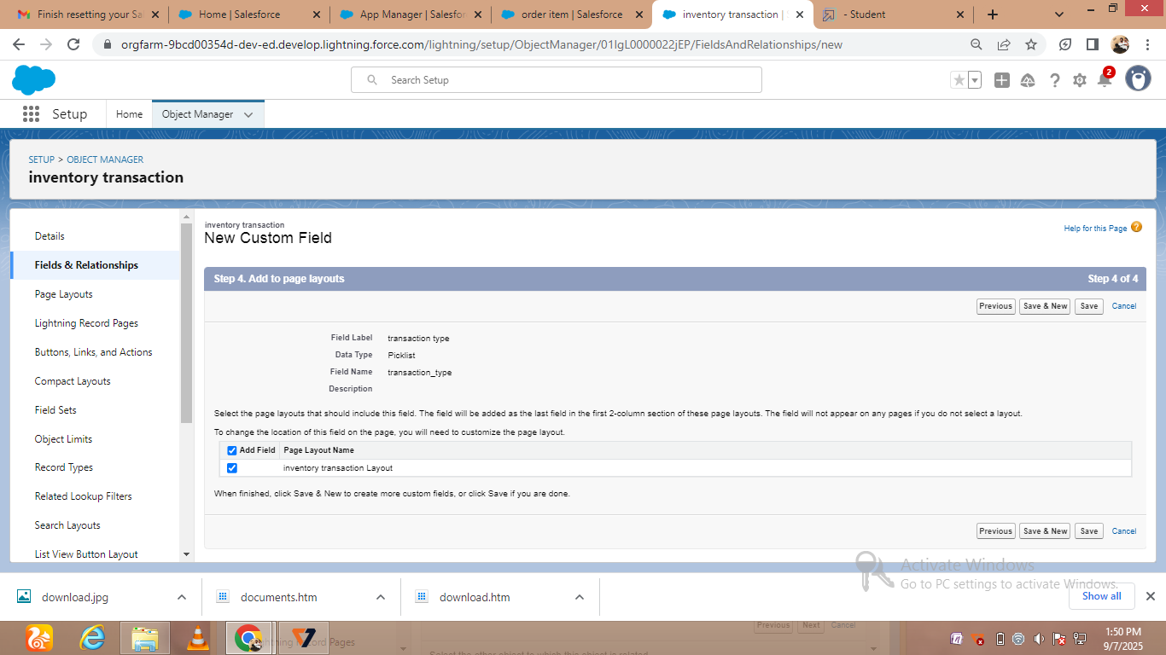

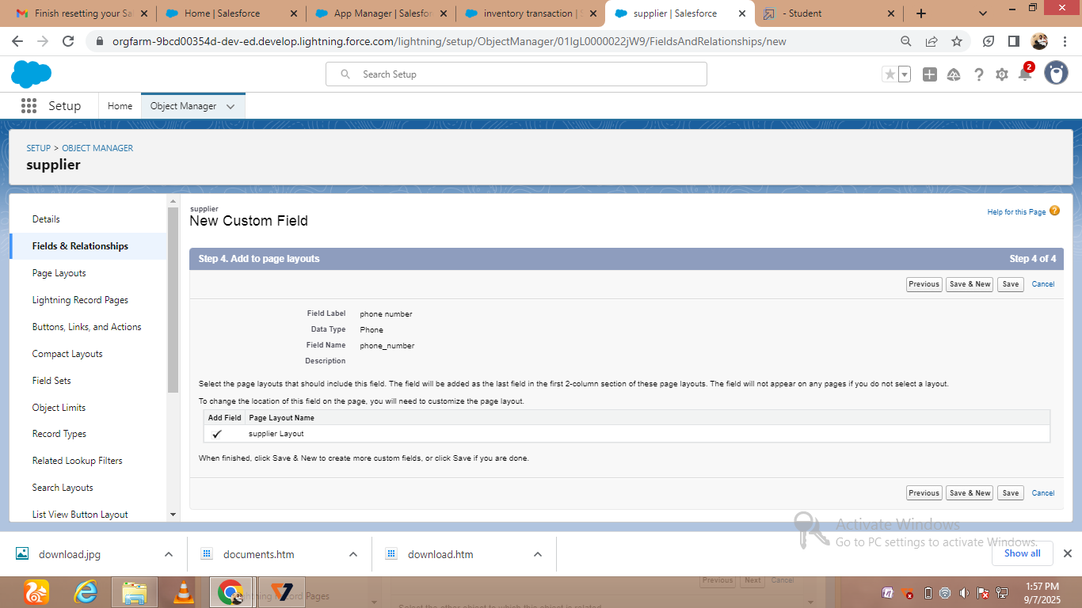

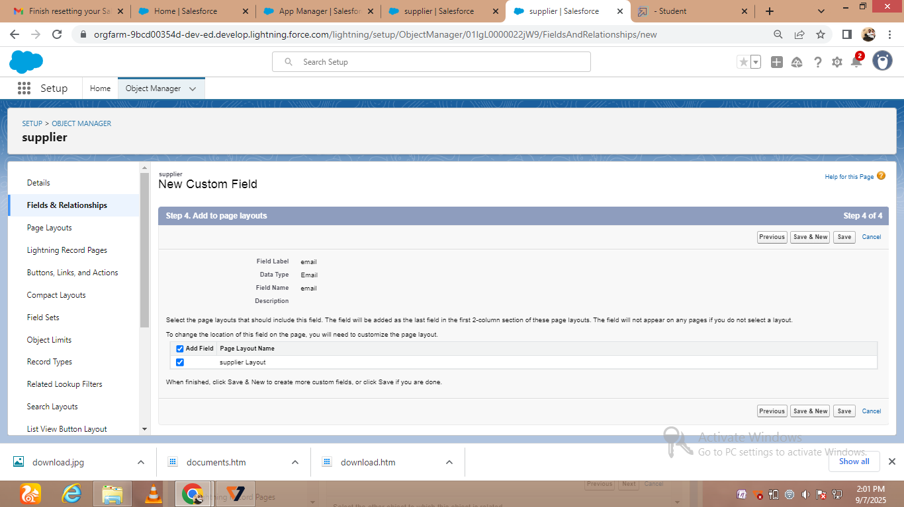

* Creating a customer product

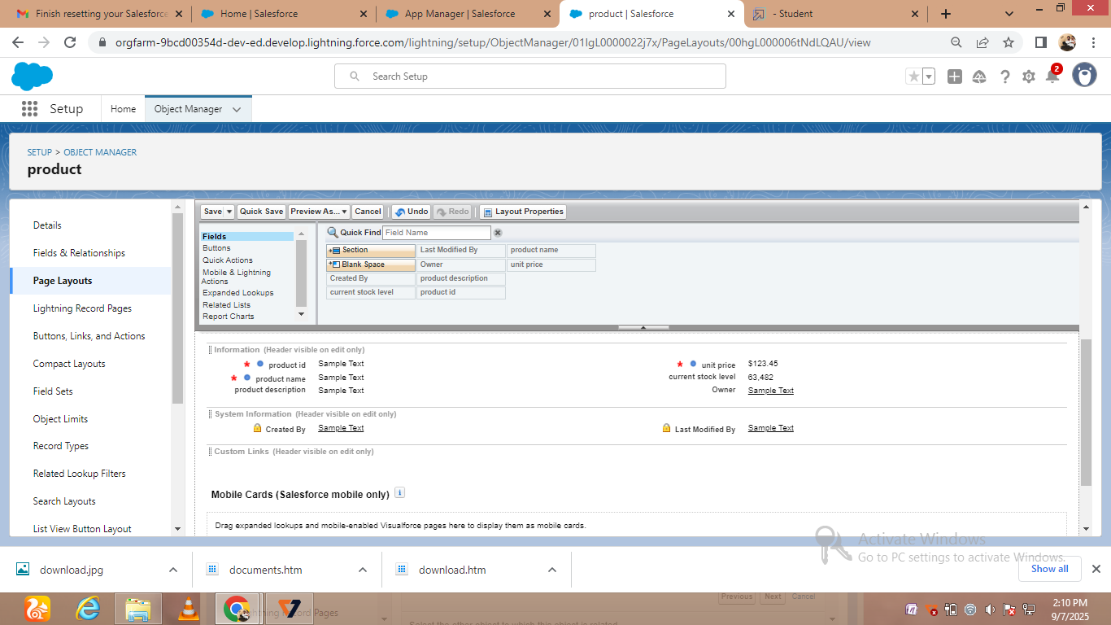

# C:\Users\THIRU\Pictures\Screenshots\Screenshot (26).png

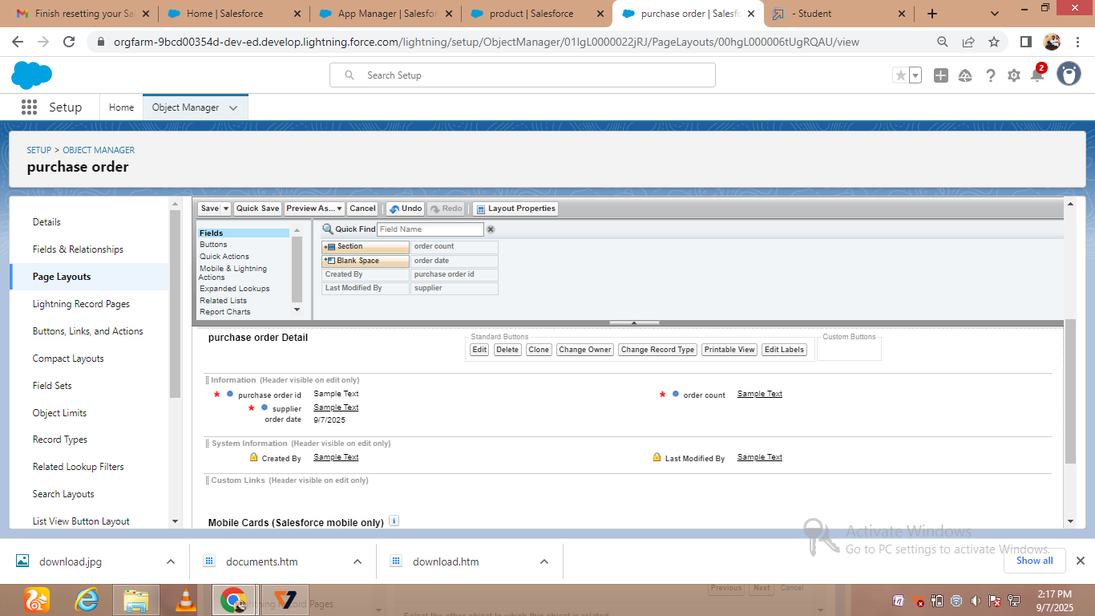

* Creating order item and transaction

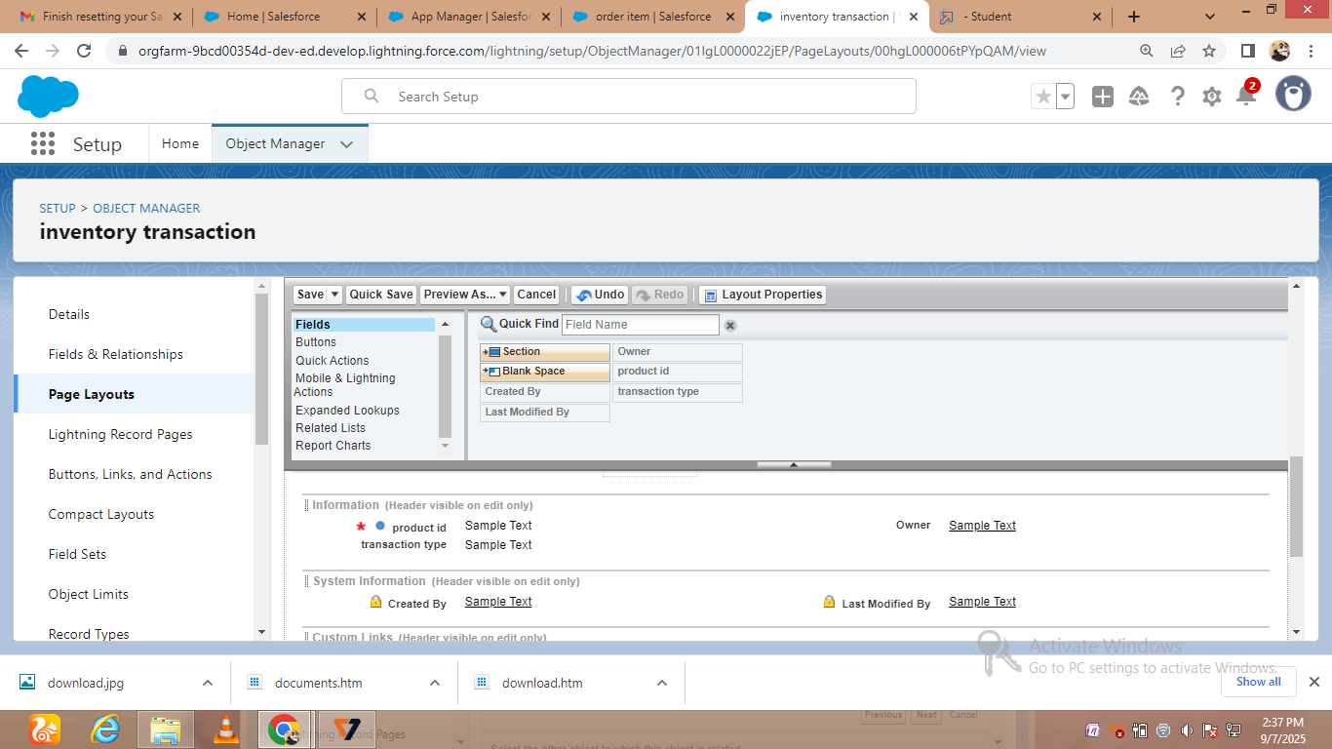

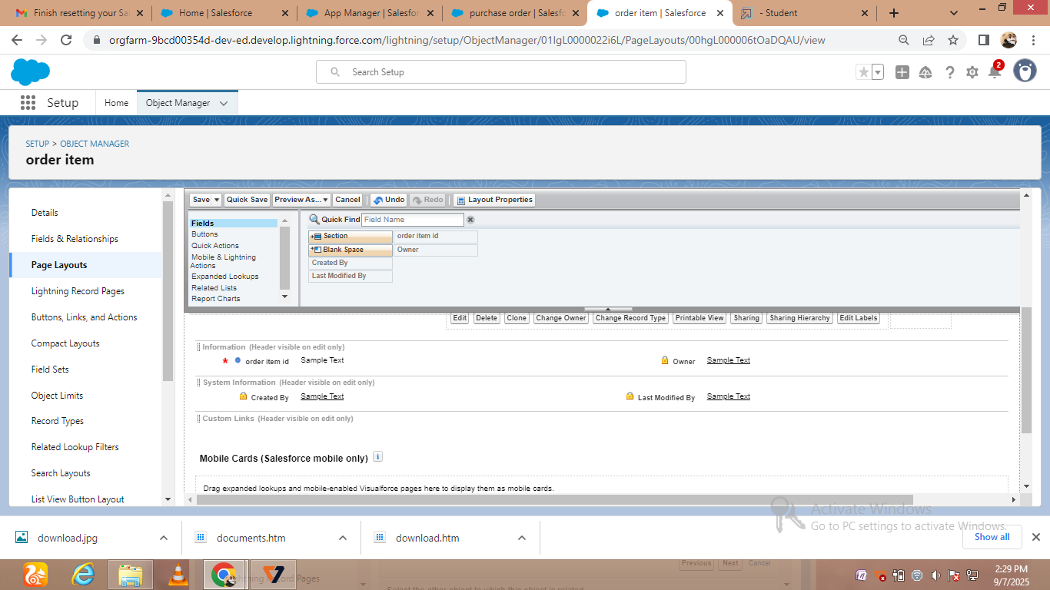



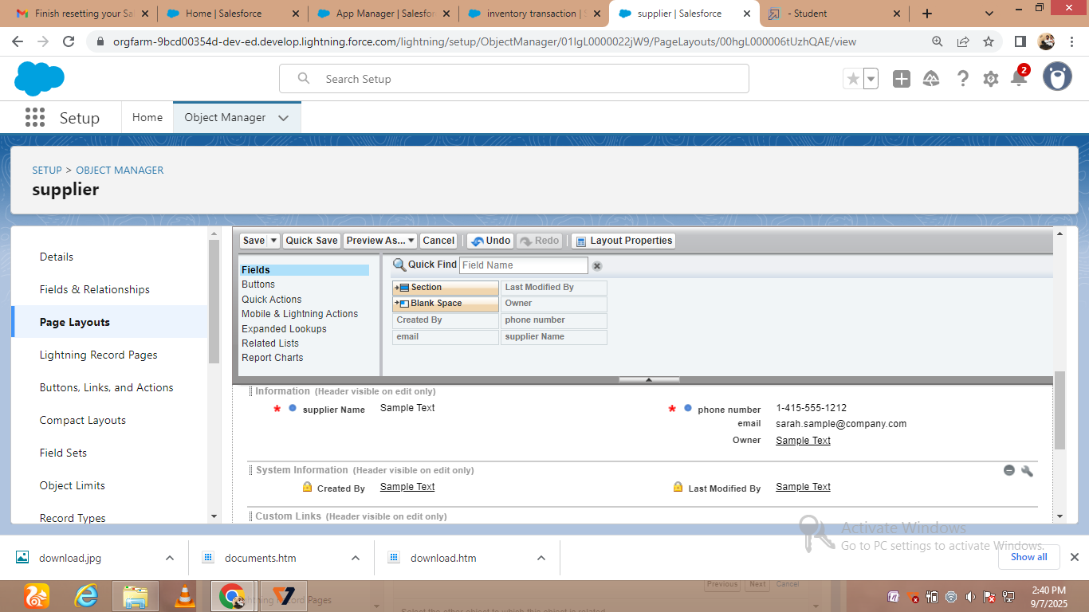

* Creating compact layouts

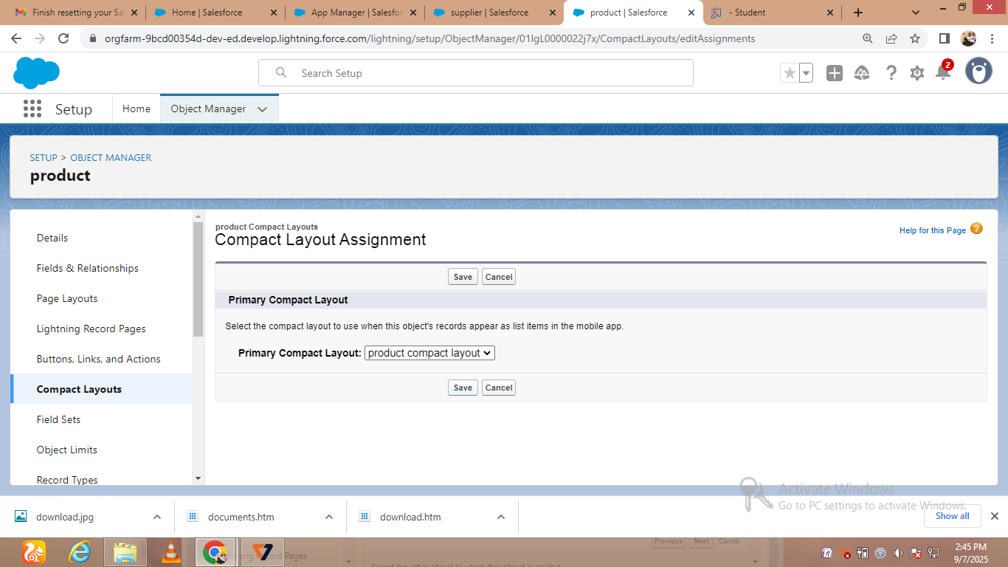

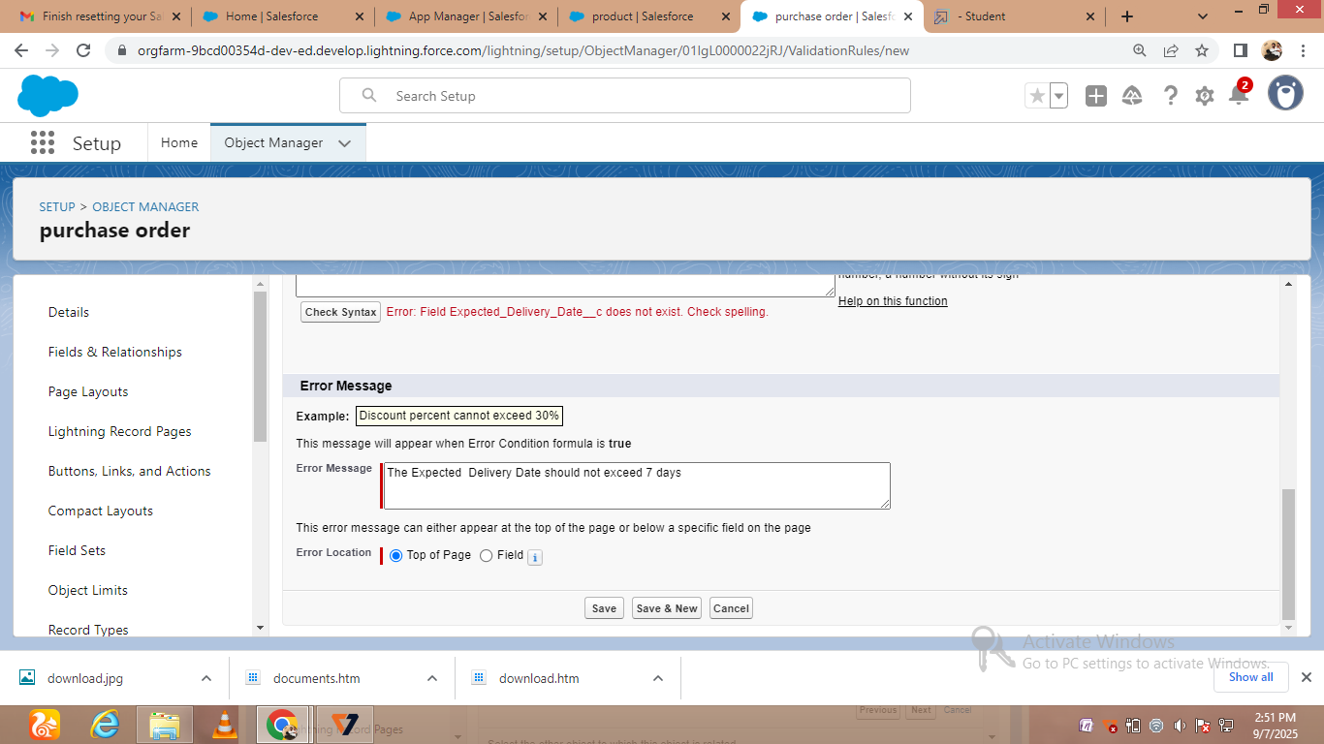

* Creating purchase order validation rule

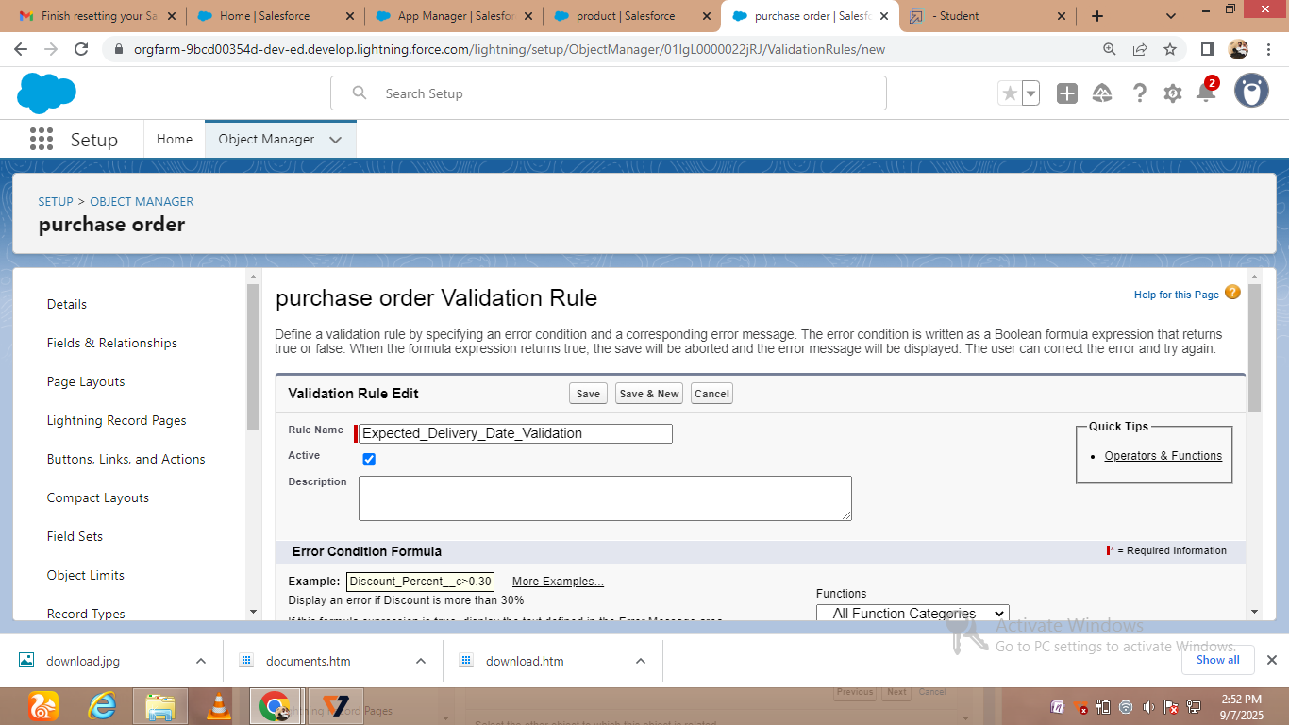

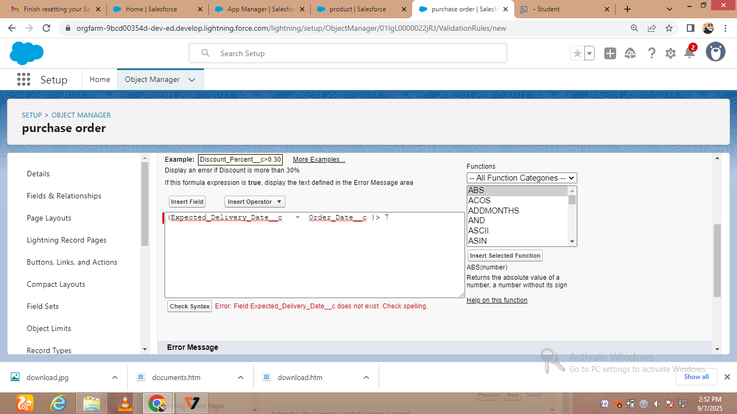



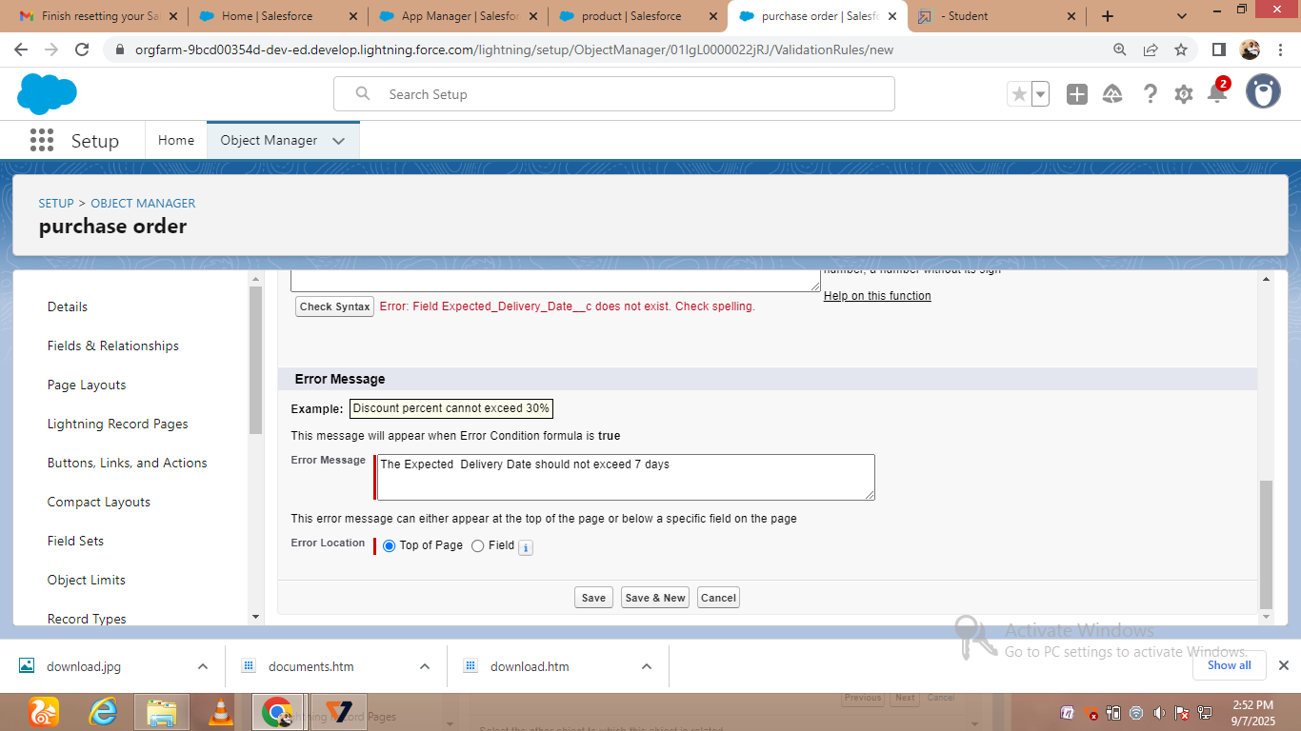

* Creating customer profiles

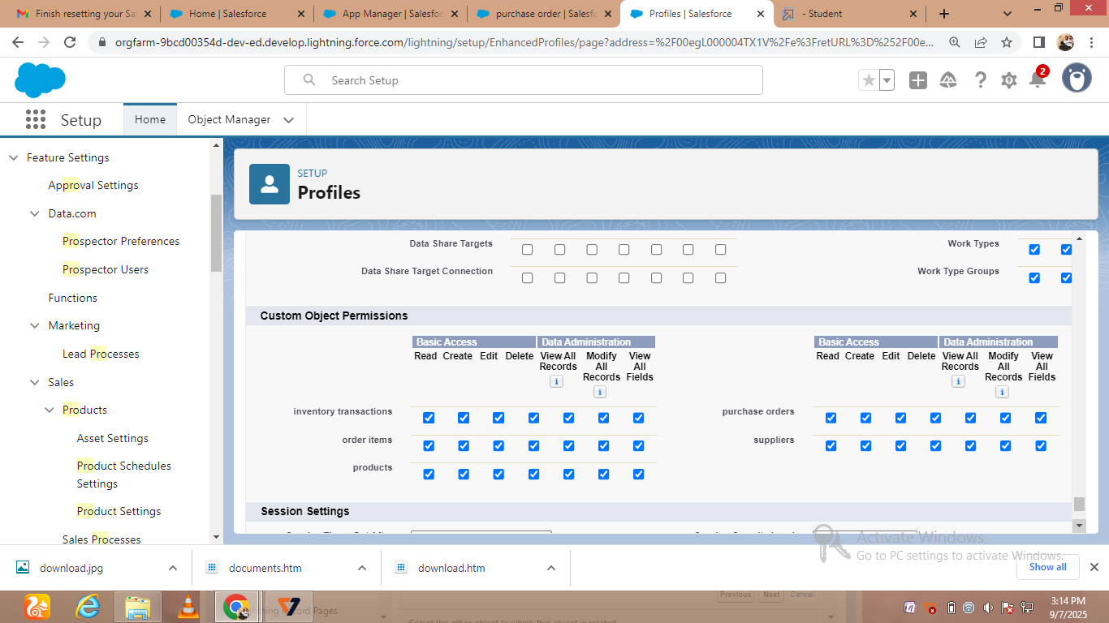

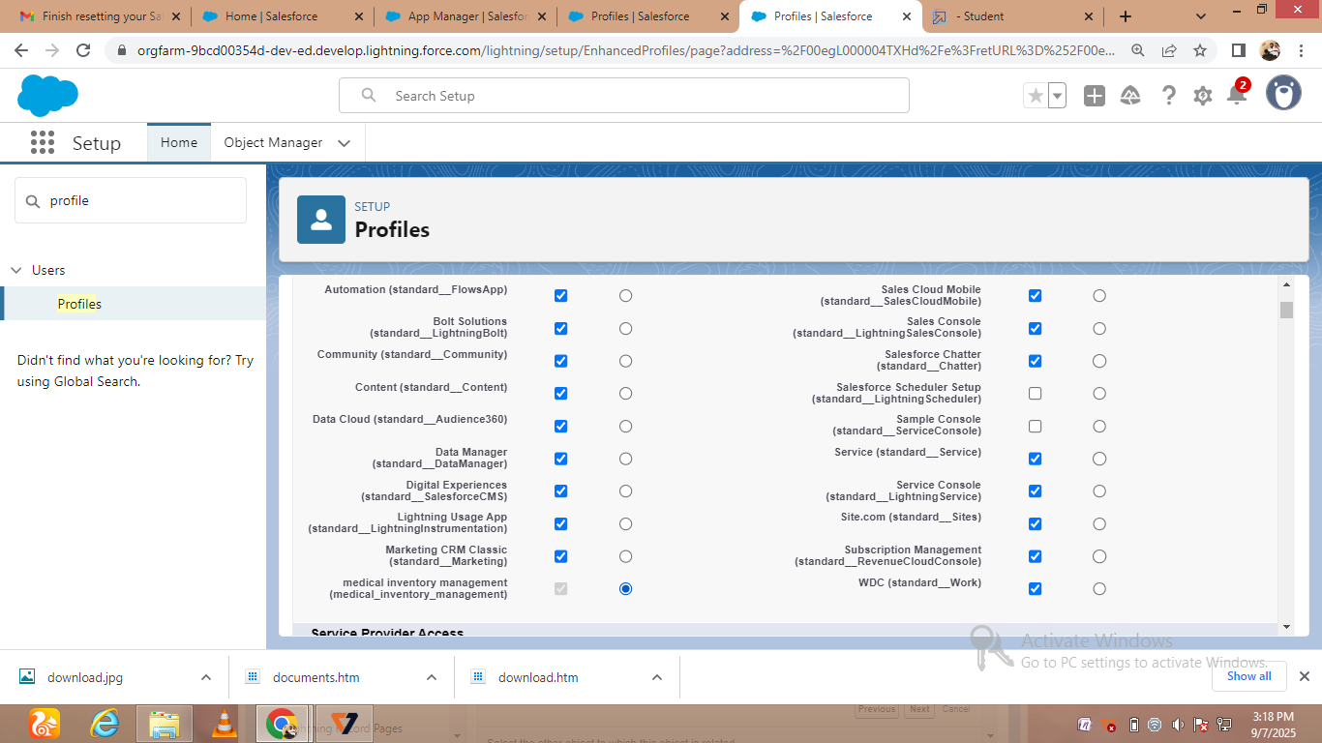

* Creating customer reports

